Pattern Recognition

LAB

Experiment-2



NAME : Ribhu Bhushan Tiwari

SAP ID : 590011166

BATCH : AI / ML (B-2)

SUBMITTED TO : Dr. Roohi Sille

**Linear Regression and Non-Linear Regression**

Linear and non-linear regression are techniques used for modeling relationships between dependent and independent variables

**Linear Regression**

Linear regression assumes a linear relationship between independent variables (X) and the dependent variable (Y). The goal is to find the best-fit line Y=mX+cY = mX + cY=mX+c, where:

* mmm: Slope of the line
* ccc: Intercept

**Algorithm for Linear Regression**

**Collect Data**: Gather labeled data with input features (X) and target values (Y).

**Initialize Parameters**: Start with initial values for the slope mmm and intercept ccc.

**Repeat**: Continue updating mmm and ccc until the loss converges or the maximum number of iterations is reached.

**Prediction**: Use the optimized mmm and ccc to predict new values.

**Non-Linear Regression**

Non-linear regression models relationships that cannot be represented by a straight line. The relationship is instead described by a more complex equation (e.g., quadratic, exponential, logarithmic).

**Algorithm for Non-Linear Regression**

**Collect Data**: Gather labeled data with input features (X) and target values (Y).

**Initialize Parameters**: Start with initial guesses for model parameters (e.g., a,b,ca, b, ca,b,c).

**Hypothesis Function**: Define the equation based on the chosen model.

**Calculate Loss**: Use MSE to measure the error between actual YYY and predicted Y^\hat{Y}Y^.

**Update Parameters**: Optimize the parameters using gradient descent or another optimization algorithm.

**Repeat**: Iterate until the loss converges.

**Prediction**: Use the optimized parameters to predict new values

**Curve Fitting for Regression**

Curve fitting involves finding the curve that best fits a set of data points, which can be linear or non-linear.

**Linear Curve Fitting:**

* Involves fitting a straight line.
* Simplified as Y=mX+cY = mX + cY=mX+c.

**Non-Linear Curve Fitting:**

* Fits more complex curves like quadratic, cubic, or exponential.

**Dataset Used**

**Dataset Name**: *Boston Housing Dataset* (or similar datasets for regression problems)

* Features: CRIM (crime rate), RM (number of rooms), LSTAT (% lower status population), etc.
* Target: MEDV (median value of owner-occupied homes)

**Preprocessing**:

* Normalize numerical data.
* Handle missing values (if any).
* Split the dataset into training and testing sets (e.g., 80% training, 20% testing).

**Code Example for Linear Regression**

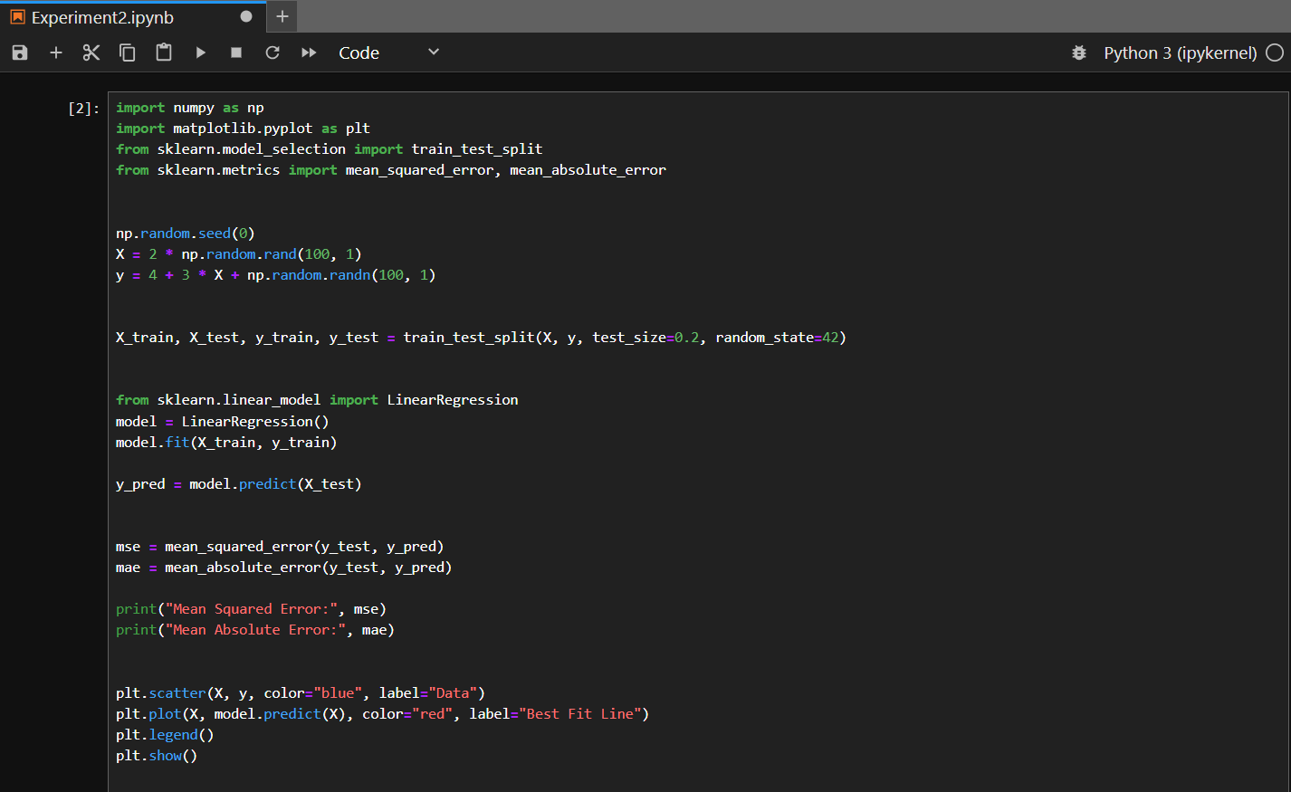

**RESULT**

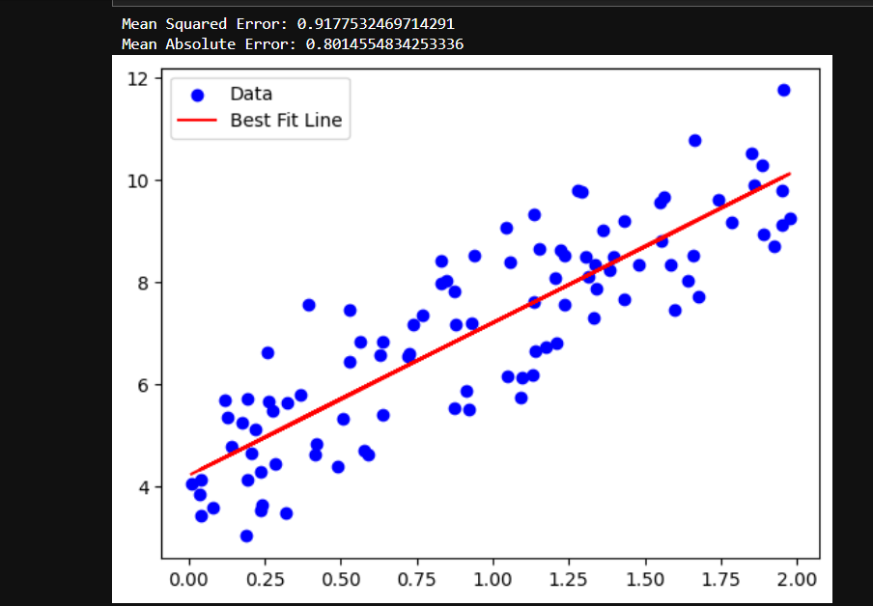

**Code Example for Non-Linear Regression**

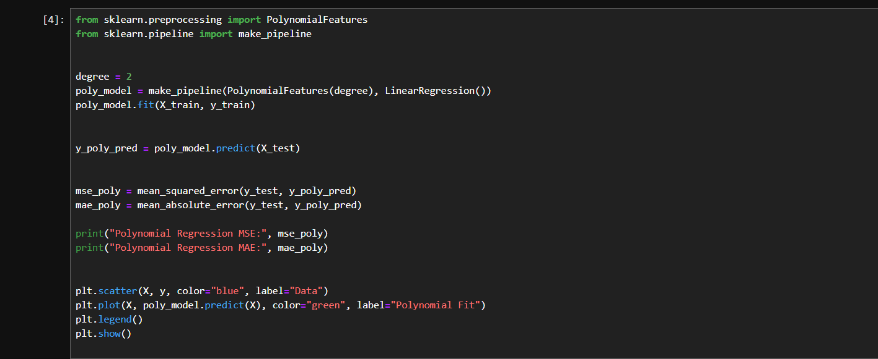

**RESULT**

